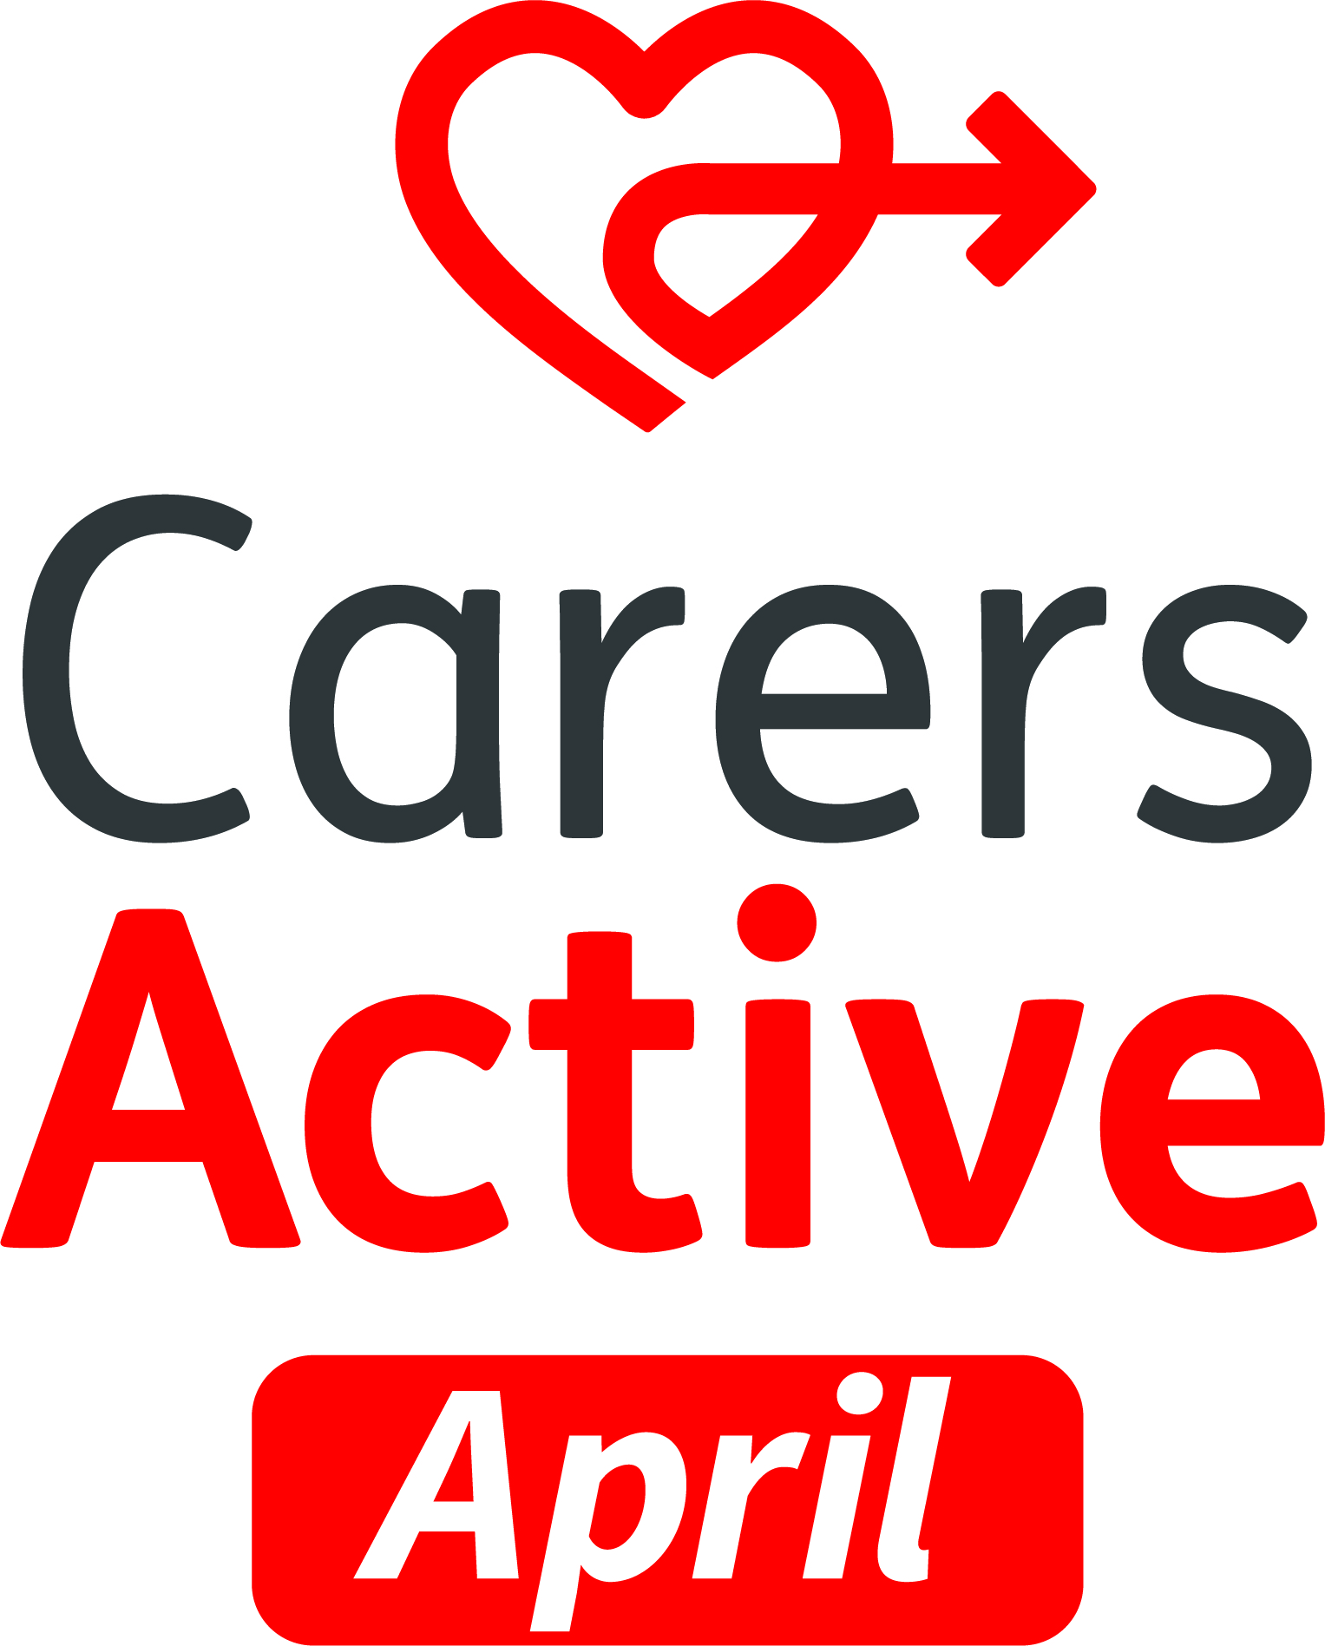

Headline:

Get active this spring and boost your health and wellbeing with the Carers Active April campaign month

Subheading:

Do you want to be more physically active? Carers UK is here to help during Carers Active April

Carers UK is again running their annual Carers Active April campaign. The campaign, which takes place throughout April 2025, will support carers to be more active by providing a range of information, resources, and activity opportunities, including online sessions, and a walking challenge. While recognising the challenges that carers face in being active, the campaign will raise awareness of the physical and mental health benefits of moving more and highlight how carers can be supported to do this. Carers will be able to access resources, tips, and information about how to balance physical activity with looking after someone.

“It gave me the incentive to exercise and take some time for me”
- carer after Carers Active April 2024

As part of Carers Active April, and linked to Carers UK’s 60th Anniversary, don’t miss out on getting involved in the ‘Paws for Carers’ 60 Mile Dog Walk Challenge. Carers UK are encouraging you to walk as much as you can, and even better if you’re able to walk 60 miles in 30 days with your dog and earn a free dog bandana as a thank you!

Find out more and register to take part for free here Paws for Carers 60 mile Dog Walk | Carers UK

How to get involved
Visit the Carers Active April page (insert hyperlink to landing page) to find out more and get active this spring! Whether you’re a carer and or a carers organisation, you can also visit the Carers Active Hub to find out more and discover a range of useful resources such as:

- Bitesize activity and wellbeing video workouts to help carers be active at a time that’s convenient.
- Recordings of Carers UK’s online physical activity sessions, including Latin dance, seated martial arts, and stretch and tone.
- Inspiration for carers and tips for getting started, plus activity ideas and resources to help carers find something they enjoy.
- Carers’ stories of getting active while caring.
- Expert advice and insight from health and social care professionals.

Look out for more details from us about this campaign in the coming weeks.

The Carers Active Facebook group is also open to any carers to join. It’s a welcoming forum where carers can support one another, share their experiences and find out how others are benefitting from regular movement. Join the Facebook group here.

To find out more about the Carers Active April campaign please contact carersactive@carersuk.org

