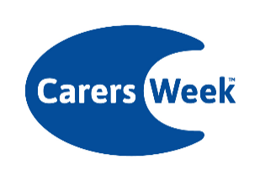Carers Week 2024 supporter pack

Social media suggested copy

There are lots of ways to get involved in #CarersWeek this week! Visit www.carersweek.org to find out more about how you can take part in loads of great activities and help put carers on the map!

We’re proud to be supporting #CarersWeek and helping put carers on the map 🗺️ Find out more and add your name to the map here 👉 www.carersweek.org

62% of those who care, or previously provided care, said they had ‘no choice’ in taking on the role because no other options were available. We’re supporting #CarersWeek to ensure unpaid carers are recognised and supported. Find out more 👉 www.carersweek.org

We’ve added our name to the map to support unpaid carers this week for #CarersWeek! Add yours now 👉 www.carersweek.org

Today #CarersWeek launch their 'No choice but to care' report, covering the impact of caring on unpaid carers. Read more 👉 www.carersweek.org
Social media graphics
Graphics for use on social media can be downloaded here.

