Young carer secures full-time employment after successful work placement
Mali a dedicated young carer, has transitioned into full-time employment following a rewarding Working Denbighshire Work Start placement. Mali’s journey began with a “Taster to Care” training course and work experience, leading her to secure a 12-week placement at Dolwen Care Home.
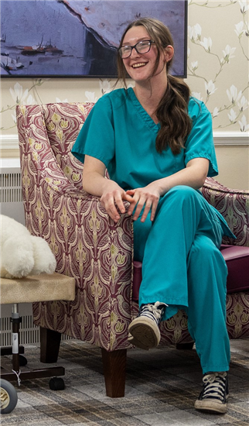
Supported by her Work Start Placement Mentor, Mali completed the application process for a permanent 24-hour contract at Dolwen, she accepted the job on her 18th birthday. Mali’s exceptional performance during the placement earned her a permanent position, marking a significant step towards a prosperous career.
The collaborative efforts by Working Denbighshire and the NHS have enabled Mali to acquire invaluable experience in her desired sector with the Work Start scheme remaining dedicated to delivering high quality work placements that yield positive outcomes for all participants.
Reflecting on her experience, Mali said:
“In completing the Work Start Schemes, I have gained experience in care that will be beneficial for me to grow in my career and continue to learn. With out the Work Start Scheme I would not have had the opportunities I have been fortunate enough to have, such as the training I have completed. The Work Start Scheme has been an incredible help in starting my journey in care, and because of this I could not recommend more highly that young people use these programmes”.
Alison Hay, Commissioning Officer said:
“Mali’s story provides a great example of the positives of being a young adult carer, Our Work Start Scheme has set Mali off on her chosen career path and provided support for her to thrive and succeed. Young Carers, like Mali develop a huge range of transferable skills from their caring role and can make excellent employees!”
Racheal Sumner-Lewis, Employer & Training Relationships Manager, Working Denbighshire said:
"We are delighted to witness Mali’s success, which highlights the effectiveness of our Work Start Scheme. By offering tailored support and matching participants with suitable opportunities, we are able to facilitate valuable experiences that pave the way to long-term employment. Mali’s journey from placement to full-time employment exemplifies the potential of our joined-up approach to workforce development."

